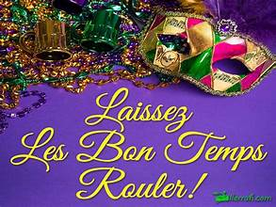

2025 February Newsletter
Message from the Leader of the Flock:
Howdy from Belize!! If you get the chance do the Meeting of Mayan's with Mike Nash, then jump on it. This has been a wonderful week, and the folks down here are awesome.
Well, we got the first month of the year behind us and now on to February.
We will have Ramblewoods at our happy hour and back at River Rose on February 13th and this will be a Mardi Gras themed happy hour. We will crown a king and queen so dress the part.
February 8th we will have a cornhole tournament at Goofy's so come out and have some fun. Goofy's does a great job with cornhole, so you don't want to miss it. Next month we have Christopher Dale coming and the highway clean up so get ready for a busy year. Don't forget to get Radio Trop Rock on your phone and join TRMA so you can support the artist. See you down the road!

Phins Up! Bubbles Up!!

Derrick Dowden (Lost Gringo)
Canyon Lake PHC President
South Region Communicator
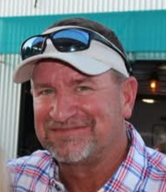

:

Message from: Viz Prez Squawk

Happy February Phlock!
After a little break, it is time for us to gear up for all the phabulous events we have planned for 2025!! It is never too early to start thinking about P4. So, all of you that have businesses, know business owners, or just use some great services, consider asking them to sponsor our event. Ask any board member for a sponsor letter, and we will get it to you!! Your help is appreciated!!

I am working on some workdays for our charities. These are days we can go in and volunteer to help with things like the thrift shop, food bank and our beloved animal shelter. I will have dates set soon, so stay tuned.

I gotta go where it’s warm!!
Phins up!!
Cheers,
MaryAnn Schott (Jetty Lady)
Canyon Lake PHC Vice-President:
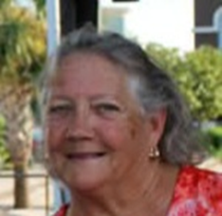

TREASURY REPORT:
Starting Balance 01/01/2025 $3315.32
General Fund $1351.42
P4 Fund $1963.90

Balance 01/29/2025 $3741.77
General Fund $1777.87
P4 Fund $1963.90

Cheers,
Brenda Newman (Bay Watch Brenda)
Canyon Lake PHC, Treasurer:
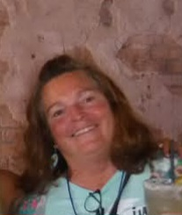

ADDITIONAL NEWS:
Please continue to save can tabs. You can bring to any CL happy hour and give to Tamara.
Up Coming Events:
2/8/2025 Canyon Lake PHC & Goofy’s Cornhole Tournament – 1pm at Goofy’s Bar & Grill. (details at the end of this newsletter)
2/13/2025 Canyon Lake PHC Happy Hour – 6:30 pm at River Rose with Ramblewoods.
2/22/2025 Billy Snipes – 3 – 6 pm at Hi Cotton (formally known as Comal Country Club)
2/26 – 3/2/2025: Music on the Bay 2025 – Tampa, FL - https://musiconthebay.org/
3/8/2025 Canyon Lake PHC Highway Cleanup – 8:30 a.m. Meet at the corner of FM 306 & Purgatory Rd. (details at the end of this newsletter)
3/15/2025 Seguin PHC – St Patrick’s Day Pub Crawl – 6 pm The fun starts at Callahans
3/22/2025 San Antonio PHC Casino Night – 6 – 9 p.m. at Harmony Hills Cabana Club, 339 Fantasia San Antonio, TX 78216.
3/27 – 30/2025: Lone Star Luau – Montgomery, TX - https://www.lonestarluau.com/
3/30/2025: Friends Cruise 7 nights, out of Galveston - Vacations To Go-Fast Deal #38473
Royal Caribbean/Harmony of the Seas 1-800-338-4962 Ext.7466- Ask to link to Debbie McNeill Group

5/16 – 18/2025: San Antonio PHC Survive – Beachgate in Port Aransas. You can reserve your rooms NOW, 10% discount. Call 361-749-5900 (any issues on rates ask for Tonya). More information to come regarding registration for this event.

6/12 – 14/2025: A1A Beach Bash – Fernandina Beach, FL - https://a1aparrotheads.org/beach-bash-2/

6/27 & 28/2025 ParrotHead Looks @ 40 Party – Cork &Barrel – Round Rock, TX. More info to come.

7/12/2025 Canyon Lake PHC River Jam – Rio Raft, Canyon Lake, TX - details coming soon

9/4 – 7/2025 Canyon Lake Parrot Heads “Phlip Phlop Phloat Phling” (P4) – Rio Raft, Canyon Lake, TX. Registration now open:
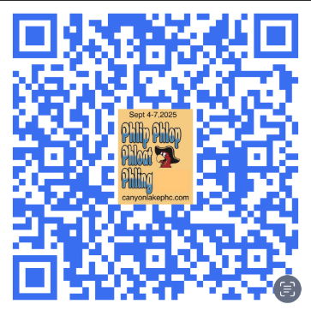

10/22 – 26/2025 Meeting of the Minds (MOTM) – Gulf Shores, AL. https://phip.com/

While planning your 2025 vacations please visit https://phip.com/regional-calendars/ . Clubs will soon be updating this calendar with their happy hours and events. I highly recommend attending another club’s happy hour / event.

House Concerts:
Look up Isla Bella & Lakeside Lanai venues on Facebook for more information.
3/01/2025 – Lakeside Lanai with Mark Mulligan.
3/16/2025- Lakeside Lanai with Dan Sullivan.
4/13/2025 – Lakeside Lanai with Jimmy Parrish.
4/19/2025 – Marley’s Vista with Mike Nash.
4/27/2025 – Lakeside Lanai with Bryton Stoll.


Join Trop Rock Music Association (TRMA) to benefit the artist.
Visit www.troprock.org and join today for only $15 a year.


Download the Radio Trop Rock app on your phone or just log onto https://radiotroprock.com/ to listen on your computer. If you haven’t tuned-in then you are definitely missing out. Oh, and it’s FREE!!

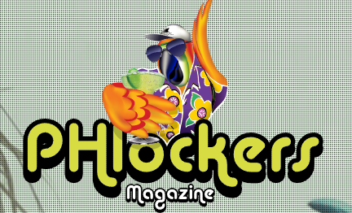
Go to https://www.phlockersmagazine.com/ to catch the latest news in the parrot head world. They always have great articles about parrot head clubs and it’s free!

Come see me at our next happy hour, Feb 13 to record your volunteer hours and ask me any questions about the above events.

Bubbles-Up,
Claudia Obeck (Bubbles)
Canyon Lake PHC Secretary:
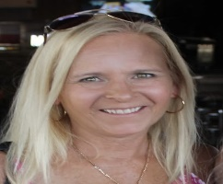

WELCOME NEW MEMBERS:


Gary Knetsch
Dee Ann Knetsch
Jared Buoy
Traci Buoy
Kent Kidd
Christine Kidd

FEBRUARY BIRTHDAYS:
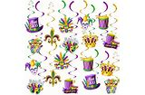

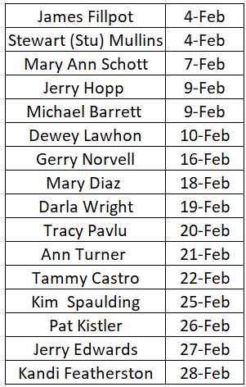

Notify Lindsay if your name is missing from the above list.

Membership Dues:
2025 Membership Dues were due in January, if you haven’t paid you can do so at happy hour or our website https://www.canyonlakephc.com/

NEW: Access the below QR you can pay membership dues or sign up a new member:

Cheers,
Lindsay Quirke (Jolly Mon)
Canyon Lake PHC; Membership Director
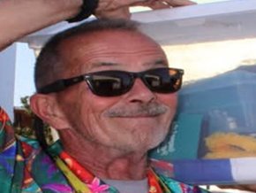

February Drink’s of the Month

Chocolate Strawberry Martini for Two
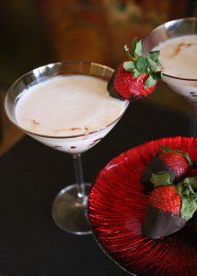

6 strawberries, sliced
3 ounces milk
6 ounces vodka
4 ounces chocolate liqueur
Chocolate syrup
Chocolate-covered strawberries (for garnish & your fancy)
2 oversized martini glasses

Directions:
In shaker, combine strawberries and milk, muddle. Add vodka and liqueur. Fill with ice and shake.

Drizzle chocolate syrup on the inside of each martini glass. Strain drink into martini glasses, and garnish with chocolate-covered strawberry. Serves two.

Sazerac
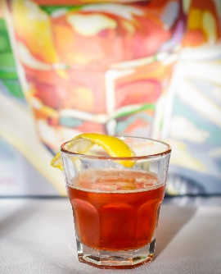
- 1 cube sugar
- 1 ½ oz Sazerac Rye Whiskey or Buffalo Trace Bourbon
- ¼ oz Herbsaint
- 3 dashes Peychaud’s Bitters
- 1 lemon peel

Directions:
Pack an old-fashioned glass with ice. In a second old-fashioned glass place the sugar
Cube and add the Peychaud’s Bitters to it, then crush the sugar cube. Add the Sazerac
Rye Whiskey or Buffalo Trace Bourbon to the second glass containing the Peychaud’s
Bitters and sugar. Remove the ice from the first glass and coat the glass with the Herbsaint, then discard the remaining Herbsaint. Empty the whiskey/bitters/sugar mixture from the second glass into the first glass and garnish with a lemon peel.

“Party with a Purpose”

Canyon January Happy Hour with Jason Grove, Timmy Nieves & Smilin Jon Whitley
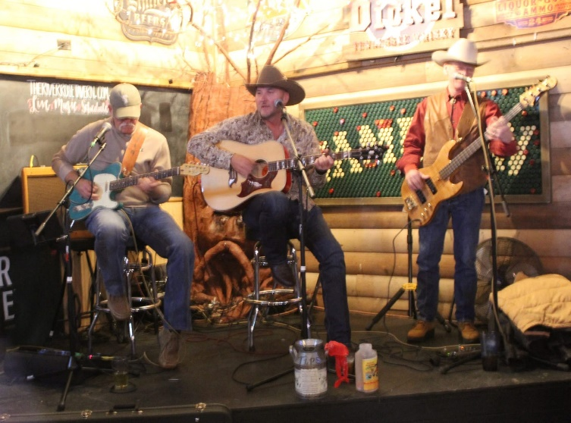

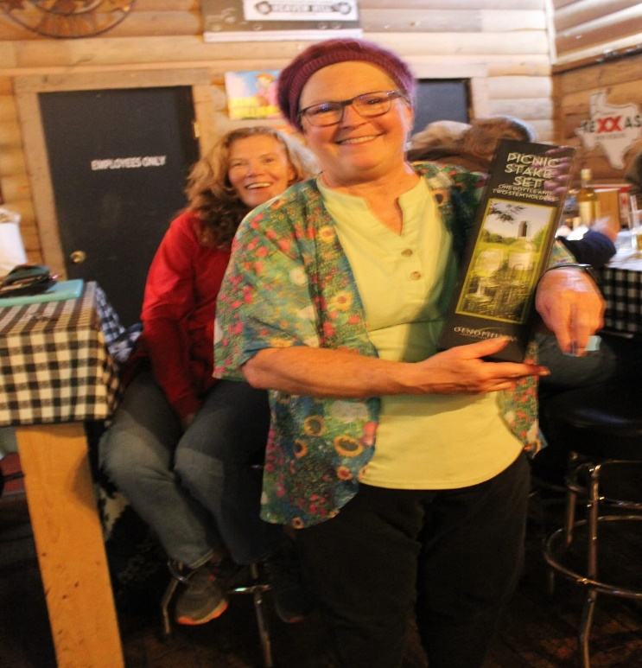

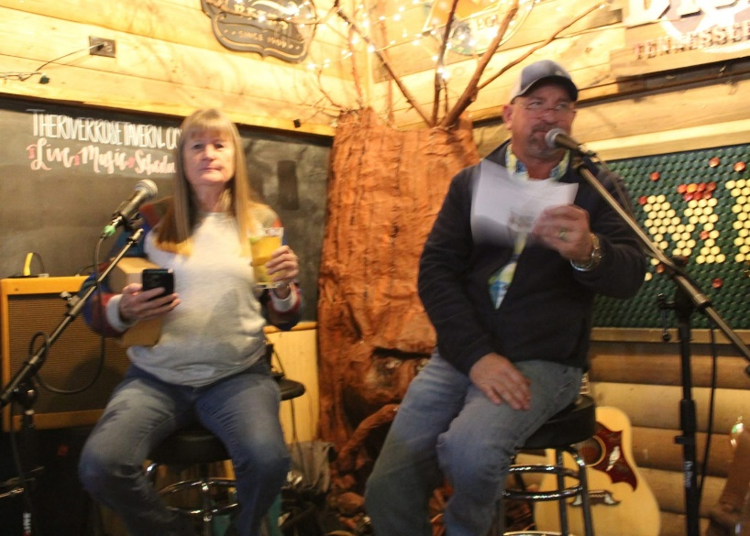

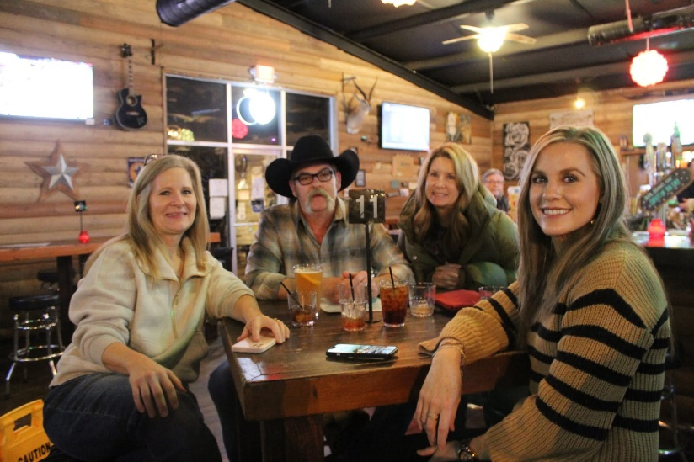

Please visit our Facebook page “Canyon Lake Parrot Heads” to see more fabulous photos by Elaine Graves.

